1. **Gateway Image Flash**

Artifacts:

* boot-dragonboard-410c.img
* rpb-console-image-dragonboard-410c.ext4.gz (For **Linux** OS)
* rpb-console-image-dragonboard-410c.img.gz (For **Windows** OS)

**Below are the steps to flash new firmware on DragonBoard™ 410c board using the fastboot method**

* **Step 1**: Make sure fastboot is set up on host computer

**Windows:**

Install Fastboot in your windows host machine from [here](https://www.getdroidtips.com/how-to-install-adb-and-fastboot-on-windows/)  
 Install Git Bash in your windows host machine

Add environment variable for adb

1. Type “path” in windows search bar.
2. Select “Edit the System Environment Variables”.
3. Click box near bottom for “Environment Variables”
4. Select “Path” in upper window then Edit.
5. Add an entry C:\adb (assuming this is the location adb was installed).
6. OK and close out of dialog boxes.

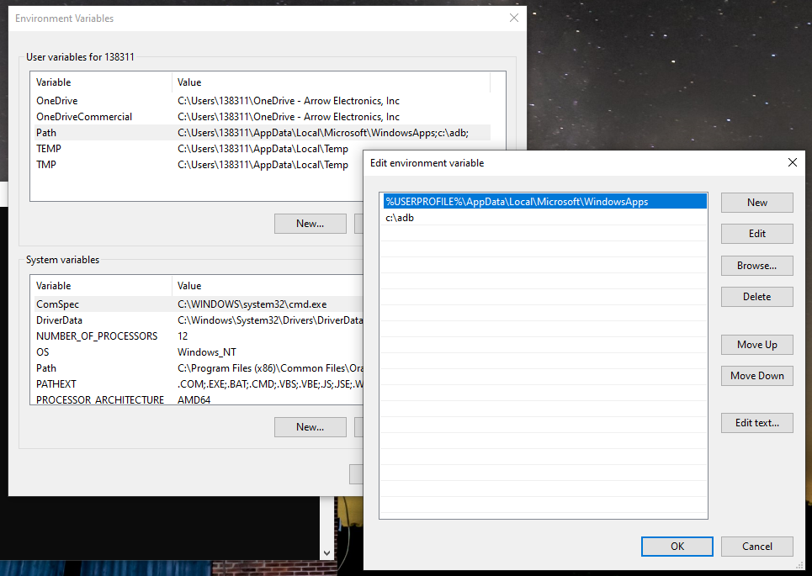

Install ADB USB Driver from here: <https://adb.clockworkmod.com/>

**Note**: Do NOT have board connected. A PC reboot likely required after install.

**Linux**:

You can install fastboot from source or using your distro package manager.

* **From source**:
* Android SDK “Tools only” for Linux can be downloaded [here](https://developer.android.com/studio/releases/platform-tools.html)
* The Linux “Tools Only” SDK download does not come with fastboot, you will need to use the Android SDK Manager to install platform-tools.
* To do this follow the “SDK Readme.txt” instructions included in your SDK “Tools Only” download.
* If you are still having trouble setting up fastboot, [click here](https://youtu.be/W_zlydVBftA) for a short tutorial video
* **Or using a distro package manager:**

# Red Hat flavor (Fedora, CentOS)  
$ sudo yum install android-tools  
  
# Debian (Ubuntu)  
$ sudo apt-get install android-tools  
   
# Ubuntu 16.04 (Xenial) and beyond  
$ sudo apt-get install android-tools-fastboot

* **Step 2:** Connect host computer to DragonBoard™ 410c
* DragonBoard™ 410c must be powered off (unplugged from power)
* Make sure microSD card slot on DragonBoard™ 410c is empty
* S6 switch on DragonBoard™ 410c must be set to ‘0-0-0-0’. All switches should be in “off” position
* Connect USB to microUSB cable from host computer to DragonBoard™ 410c
* **Step 3:** Boot DragonBoard 410c into fastboot mode
* **Please read all bullet points before attempting**
* Press and hold the Vol (-) button on the DragonBoard™ 410c, this is the S4 button. DragonBoard™ 410c should still NOT be powered on
* While holding the Vol (-) button, power on the DragonBoard™ 410c by plugging it in
* Once DragonBoard™ 410c is plugged into power, release your hold on the Vol (-) button.
* Wait for about 20 seconds.
* Board should boot into fastboot mode.
* From the connected host machine terminal window, run the following commands:
* #Check to make sure device is connected and in fastboot mode  
  $ sudo fastboot devices (**Linux**)  
  $ fastboot devices (**Windows**)
* Typically, it will show as below

$ de82318 fastboot

**At this point you should be connected to your DragonBoard™ 410c with a USB to microUSB cable. Your DragonBoard™ 410c should be booted into fastboot mode and ready to be flashed with the appropriate images.**

* **Step 4:** Flash Bootloader
* Use host computer
* Open “Terminal” application

For **Windows** (Open Git Bash)

* Bootloader file should be named on ondrive in Gateway folder  
  dragonboard-410c-bootloader-emmc-Y-XX.zip
* Recall location of Bootloader download from onedrive
* Y represents Android or Linux
* XX represents the release number of the Bootloader
* Using Terminal (Linux) or Git Bash (Windows), cd to the directory with your unzipped **Bootloader Folder**
* $ cd <extraction directory>  
  #Example:  
  cd /Users/YourUserName/Downloads  
  #<extraction directory> = /Users/YourUserName/Downloads  
  #For this example we assume the "Bootloader" is in the Downloads folder.  
    
  $ cd <unzipped Bootloader folder>  
  #Example:  
  cd dragonboard-410c-bootloader-emmc-linux-137  
  #<unzipped Bootloader folder> =   
  dragonboard-410c-bootloader-emmc-linux-137  
  #This example took place during release 137  
    
  # This command will execute the flashall script within the bootloader folder  
  $ sudo ./flashall (**Linux**)  
  $ ./flashall (**Windows**)
  + The bootloader has now been flashed to the eMMC. Rebooting will launch the newly-flashed boot loader, which will allow us to flash the remaining parts of the operating system.

# Reboot the system so we can flash the rest.  
$ sudo fastboot reboot (**Linux**)  
$ fastboot reboot (**Windows**)

* **Step 5:** Copy the artifacts to specific location on your host machine
* **Step 6:** Unzip and flash files to the DragonBoard™ 410c

**Linux**

$ gunzip rpb-console-image-dragonboard-410c.ext4.gz  
$ sudo fastboot flash boot boot-dragonboard-410c.img  
$ sudo fastboot flash rootfs rpb-console-image-dragonboard-410c.ext4

**Windows**

Unzip rpb-console-image-dragonboard-410c.img.gz  
  
$ fastboot flash boot boot-dragonboard-410c.img  
$ fastboot flash rootfs rpb-console-image-dragonboard-410c.img

**Note**: the second file will take about 100 seconds to load.

* **Step 7:** Reboot DragonBoard 410c

$ sudo fastboot reboot (**Linux**)  
$ fastboot reboot (**Windows**)

1. **Sentimate sensor Firmware Flash**

Artifacts:

* Sentimate_ZigBee.bin

**Below are the steps to flash new firmware on Sentimate board**

* **Step 1**: Connect Sentimate board with WSTK board
* Once you open Sentimate board, you will also see two JTAG serial ports, the one is on power supply side that is for the ZGM130S037HGN1 module having labeled “JTAG ZWAVE” while the other one is for the MGM13P12F512GA module having labeled “JTAG MGM”
* Connect to JTAG MGM. Make sure the red wire is on the right side, in correspondence of a “1” written on the green layer.
* Do NOT power up the SENTIMATE. Connect JTAG to “CORTEX” port on STK board. Board will receive power over JTAG.
* **Step 2**: Copy the artifacts to specific location on your host machine
* **Step 3**: Open **simplicity commander** from Simplicity IDE  
   Switch to Launcher Tab in IDE. By clicking on tools button “Tools Dialog” will   
   be opened.  
   Select **simplicity commander** from menu.
* Click “Connect” on the first row and then “Connect” on the second row. It should detect the board.

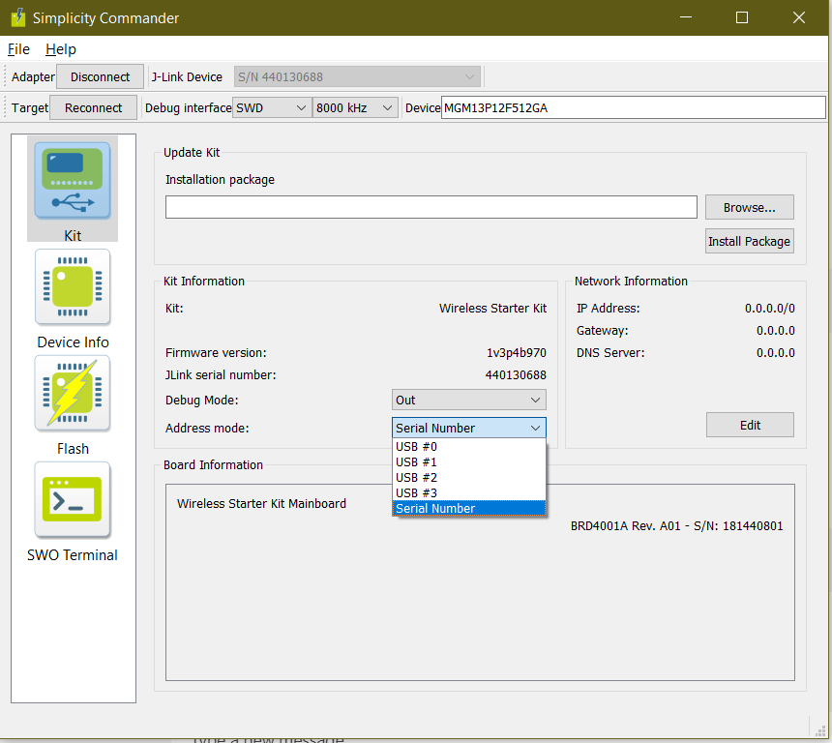

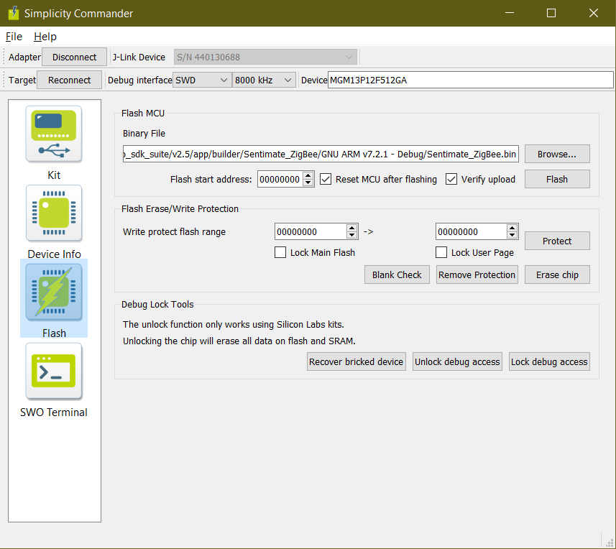

* Select Browse and select Sentimate_ZigBee.bin
* Press Flash button. Wait until it’s done.
* If you programmed the board correctly, you should see that the led starts blinking in red.

1. **Android Mobile Application**

* Copy the Application file into your Android Mobile Phone.
* Artifacts: **EFR32_Gateway.apk**
* Install the application and follow the "ei_EFR32_Gateway_Mobile_Application_User_Manual" for Gateway and Sensor provision.